GCC newsletter for the young environmentalist awards

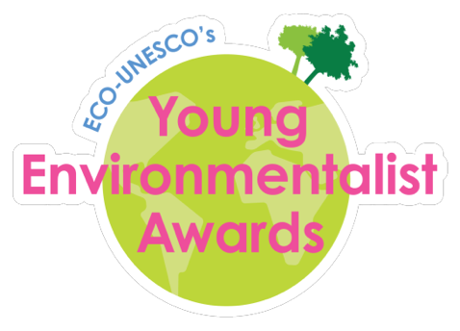

GCC students compete in environmental competition.

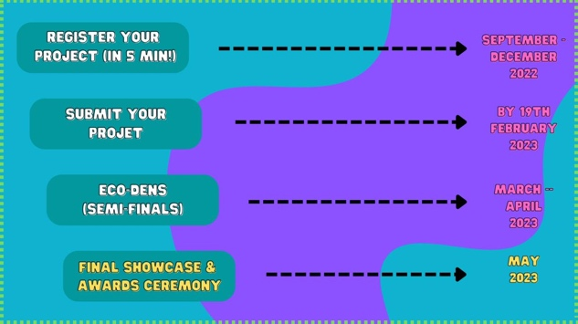The Young Environmentalist Awards (YEA) is an all-Ireland environmental competition that recognises and rewards young people who raise environmental awareness and improve the environment.

The team consisting of 4th year students Toby Tangney, Ciara Worley, Aisling O’Sullivan and Adam Hayes are entering the competition under the water category and their project will be biased around the causes and impacts of the degrading water river quality in Ireland.